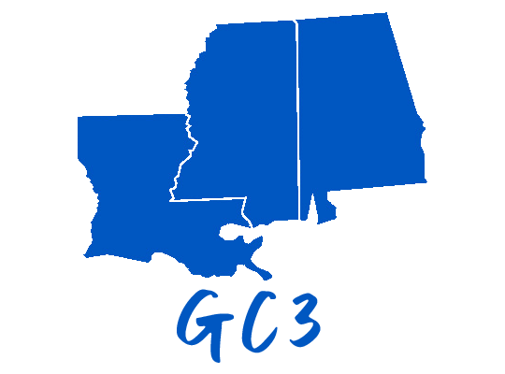

Gulf Coast 3 (GC3)

Call for Speakers – 2024 Annual Conference
Nov 13-15, 2024 (Weds – Fri) Renaissance Mobile Riverview Plaza Hotel, Mobile, AL

General Information:
The 2024 Gulf Coast (GC3) Conference seeks timely, topical presentations for our annual educational conference! This event will be held at the Renaissance Riverview Hotel in Mobile, AL, November 13 – 15th. This conference provides education, information, resource sharing, collaboration, networking, program development and a student poster competition. The conference attendees include healthcare information and technology professionals, healthcare executives, nurses, clinicians, operations and advocacy staff. There is an active student component and attendance as well.

Topics For Proposals:
GC3 seeks topics that are timely, relevant and relatable. The topic areas are intentionally broad in order to ensure a wide range of subjects. The topic areas are (in no particular order):
- Regulatory/Legislative/Governance
  - Policy
  - Planning

- Virtual Care
  - Care from a distance (i.e. digital health, telehealth, connected devices, virtual reality/augmented reality)
- Diagnostic Acumen
  - Tools that help clinicians including AI/ML/data integration
  - Tools that help processes (including change management)
  - Tools that integrate data

- Consumer-led Healthcare and Patient Engagement
  - Emerging industry care providers
  - Consumer platforms
  - Consumer personal health records and data sharing
  - Wearable devices

- Health Equity/Social Determinants
  - Integrating public health
- IT Infrastructure/Devices/Workflow
  - Wearable devices
  - Security - cyber
  - Networks
  - Remote Patient Monitoring

- Data and its Stewardship
- Workforce Issues
  - Capacity
  - Competency
  - Retention
  - Credentials
- Public Health
- Artificial Intelligence

Selection Process:
Speaker submissions are peer-reviewed and selected based on quality and clarity of content, subject relevance, and strength of learning objectives. Final speaker determinations will be communicated to you by email.
To be eligible for consideration, please complete and submit the form below in its entirety by Monday, May 1, 2024. You are encouraged to make early submissions.
Important Dates:
- May 1, 2024 – Proposal submission date. Submissions must include: short biography, headshot, session title & description, and 3 learning objectives.
- June 19, 2024 – Selection notification date.
- August 16, 2024 – Presentation submission date. Late presentations, those that do not reflect the approved proposal, or those that include promotional content may be removed from the conference agenda. A committee will review and approve presentations as received.

Additional Requirements:
- Sessions should be original and should not have been presented at other conferences.
- is a noncommercial forum. For this reason, sessions must be vendor neutral; sessions promoting a product, or a company will not be selected.
- Sessions will be 45 minutes in length, allowing 5-10 minutes at the end for questions & answers.
- Speakers must provide all conference materials including presentation slides by deadlines.
- Speaker electronic presentations will be made available to conference attendees.
- Speaker conference attendance fees are waived, although individual travel and expenses are the responsibility of the speaker.
- You are welcome to submit as many session proposals as you would like.

Please Note:
Your presentation must not be a sales pitch for any services, products, association, or company. GC3 has the right to refuse and/or suggest changes to content. If GC3 receives a complaint that your presentation was in any way considered commercial, it may impact future speaking opportunities.
Speakers are required to use the GS3 presentation template.

Gulf Coast (GC3) 2024 Annual Conference
Speaker Presentation Proposal

Primary Presenter
Name |  | Credentials
Title |  | Organization
Phone |  | Email
Short Bio

Co-Presenter
Name |  | Credentials
Title |  | Organization
Phone |  | Email
Short Bio

Topic of Presentation (select all that apply)

☐ Regulatory/Legislative/Governance
☐ Care Giving and Care Giving Technology and Information Tools Including Innovation
☐ Consumer Led/Focused Healthcare
☐ Data and its Stewardship
☐ Health Equity/Social Determinants
☐ I. T. Infrastructure
☐ Interoperability and Information Blocking
☐ Public Health
☐ Virtual Care
☐ Artificial Intelligence
☐ Workforce Issues

☐ Other: ______________________________________________________________________

Session Title:
Session Description:

Learning Objectives - Please list three

- ________________________________________________________________________
- ________________________________________________________________________
- ________________________________________________________________________

Desirable Attributes Addressed by Presentation (select all that apply)
☐ Quality Improvement
☐ Evidence Based Practice
☐ Healthcare Innovation
☐ Interpersonal and Communication Skills
☐ Process Improvement
☐ Practice-based Learning and Improvement
☐ Professionalism/Leadership
☐ Patient-Centered Care
☐ Financial Impact
☐ Informatics

Intended Audience:

☐ Administration/Healthcare Executives Financial Management
☐ Health IT
☐ Health Informatics
☐ Operations
☐ Organizational Governance
☐ Personal/Professional Development
☐ Physician/Non-Physician Providers
☐ Risk Management/Compliance
☐ Other: ______________________________

Audio/Visual Needs:

GC3 will provide a laptop, projector, and microphone. Please indicate whether you need Internet access or any other A/V needs.

☐ Yes ☐ No, or other AV need: ________________________________________________

Please make sure your session description is as complete and meaningful as possible. Use as much space as needed, the description is not limited to the space allocated in this form. Attach any and all support materials you wish to include at this time.

✓ By inserting your initials below, the speaker grants permission to distribute materials and record presentations at the 2024 GC3 Meeting.
Initial here:

Please submit your questions and completed speaker proposal forms to gc3conference@gmail.com with Email Subject: GC3 Speaker Proposal.

We thank you for your interest!

